RG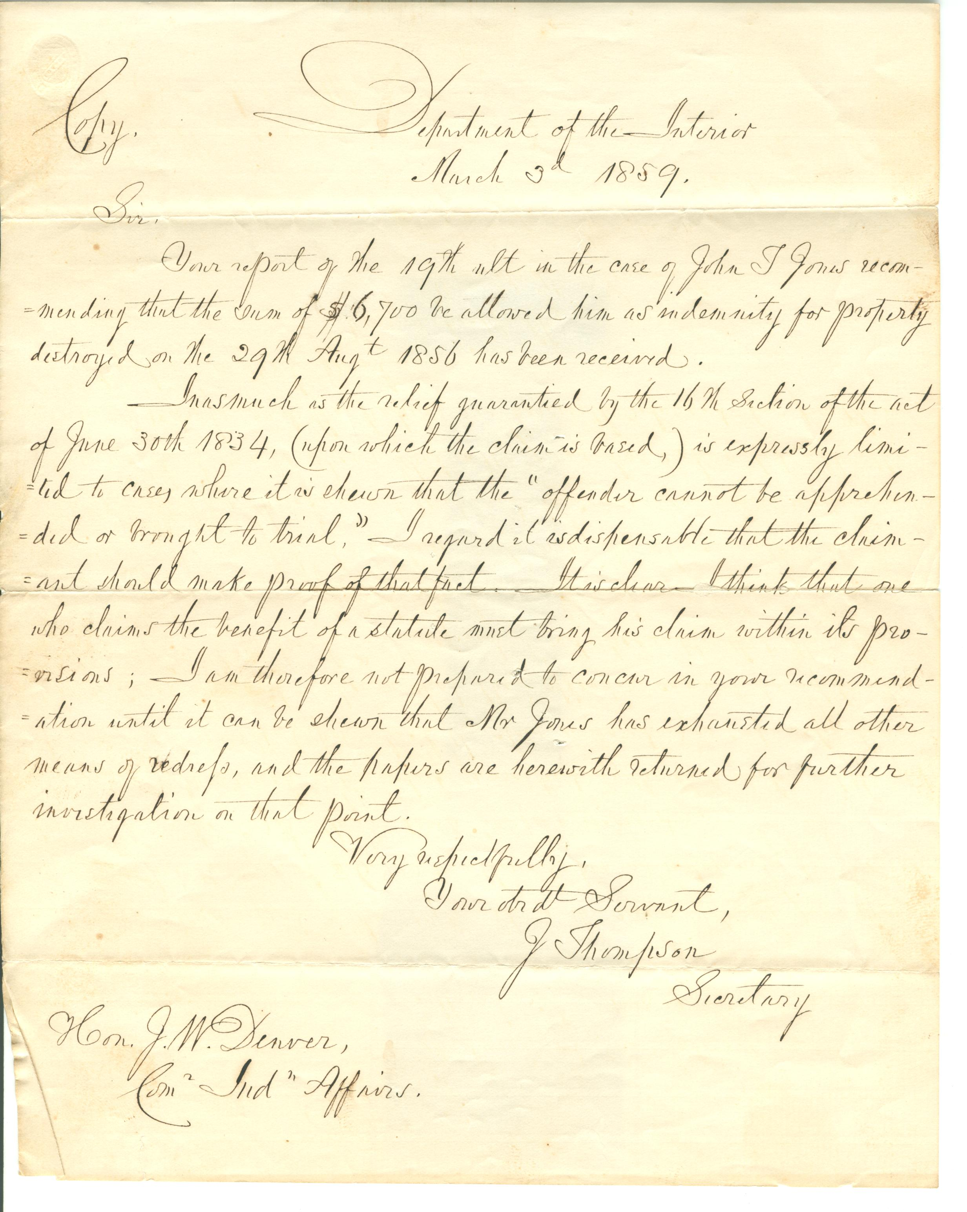75.185 page 1
Lawrence, KS
Sept 25, 1867

Bro Jones
I received your note
in regard to a meeting of the Trustees, Fs. At the time, I was expecting to visit your vicinity in company with the Committee of the Convention. But we missed connection, and I did not see them. Now I learn incidentally that the New York brethren have been there and done their work. Mr. Kalloch is all over the lot, and never writes me. I wish, if it

RG75.185 page 2
there is any work we should attend to, you would give me timely notice. I hope things may be taking a favorable turn, though I have no information as to what has been said or done.
Give my love to Mrs Jones.
Yours Truly Mrs
John G. Pratt.

