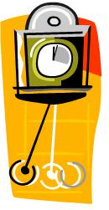
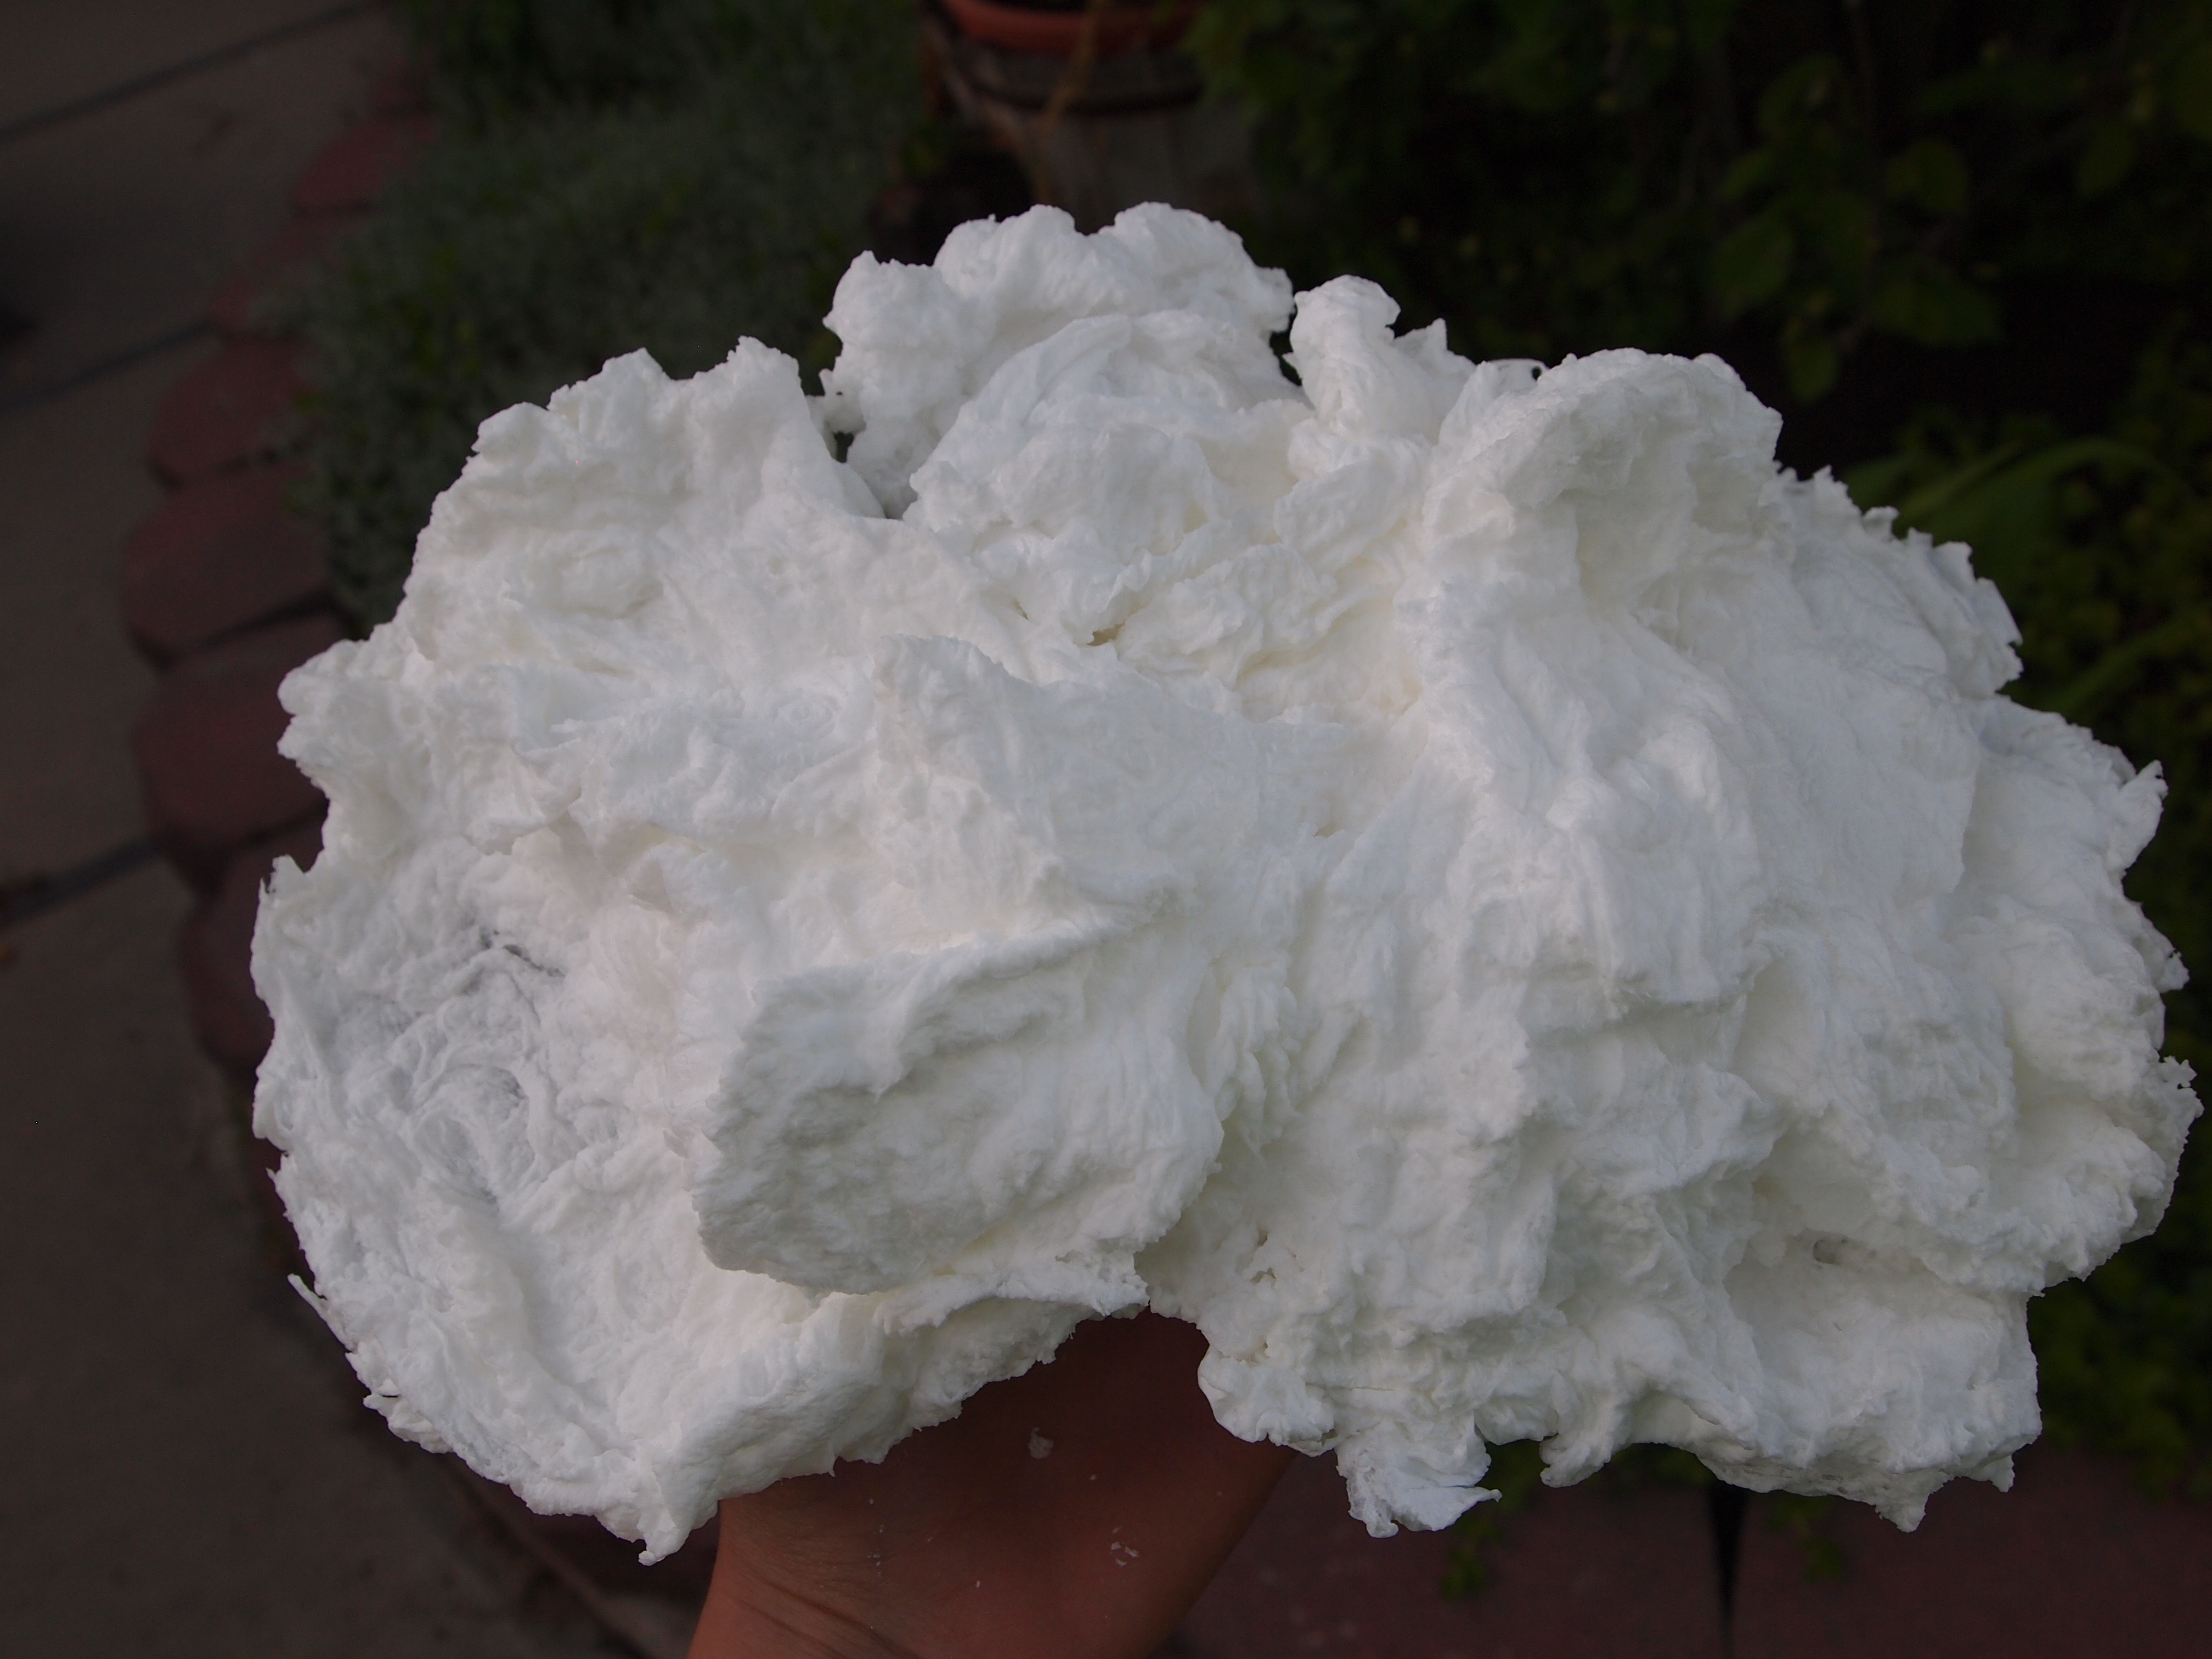
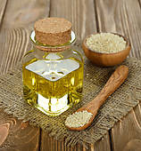
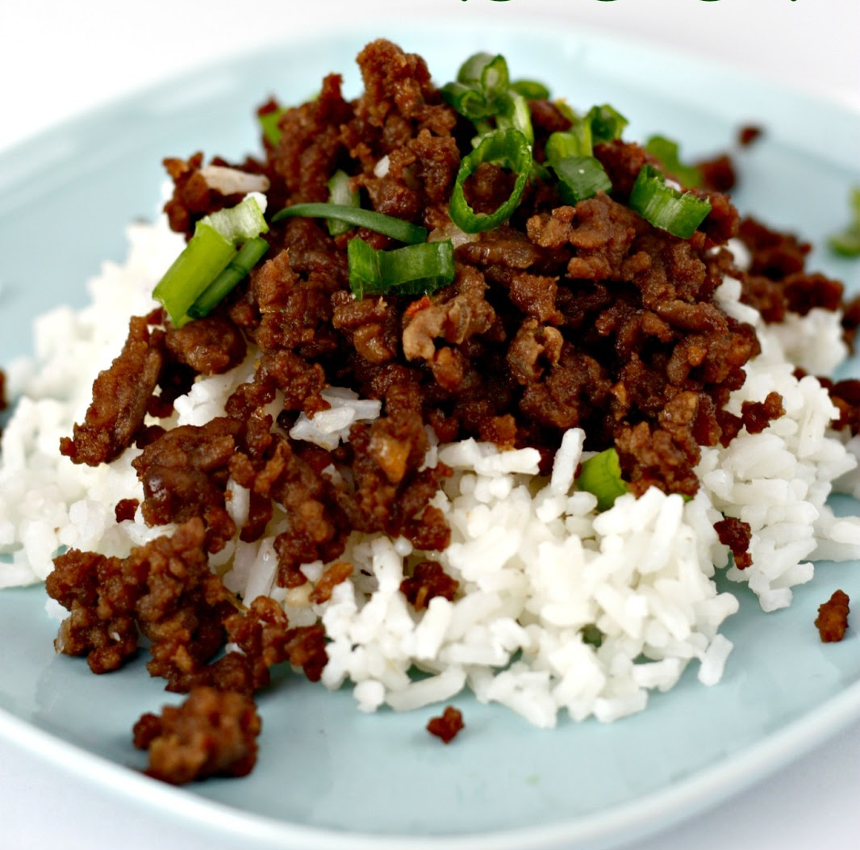
Welcome to the New Year, a new beginning, and all the possibilities that come our way. I recently read a quote by C. S. Lewis that always sums up this time of year for me, “There are far better things ahead than any we leave behind.” Each moment of your day holds importance. However, the importance is fleeting and swings from moment to moment. Where our attention lies becomes the moments that define our day. Spending our attention on 2014 robs us of focusing on the moments that are now 2015. The “better things” are always coming, the question is are we still pining for the lost moments of our past or are we ready to swing in and experience the newness of what’s to come. If you are into writing resolutions or simply taking a look a head, be thankful for the moments that you were able to enjoy and ride that pendulum into the coming new year ready to embrace all that 2015 has to offer. Knowing that all good things end, so that they can begin again. Happy New Year.

Dates to remember:
Moderate Cold
Jan. 6th

Severe Cold
Jan. 20th

If you never stretch your limits, you’ll never reset your limits! Creating the cutting edge requires innovative action and leadership that isn’t afraid of getting messy and uncomfortable. Discomfort is a crucial ingredient in developing your leadership capacity and ultimately makes you stronger and more resilient. Consider how your life would change if you were willing to put yourself out there more and simply try something new without any attachment to the outcome. In fact, some of the most famous geniuses and savants throughout history only made their discoveries because they were willing to face failure, persevere, and continue experimenting. So go ahead and get uncomfortable! Be BOLD, Take RISKS. Create CHANGE. Experience FAILURE. And through it all, you will conquer the chaos that creates clarity and change in your life! --Adapted from Leading with Intention

Issue #5, Jan. 2015

Better Things Ahead

Get Uncomfortable Often

the pendulum
Got a microwave? Got a bar of ivory soap? You’ve got a potential abstract soap cloud sculpture. To be sure watching this sculpture take form is a delight. If you have a turntable in your microwave you’ll need to take it out first. Then put a paper towel in and place the bar of soap in the middle. Set the timer for about two minutes. Press start and watch the magic happen. You’ll probably want to stop it before the two minutes are up; just keep watching, when it stops growing take it out. Once it cools you can use it in the bath or display it on your mantle to all your friends and family.
Ingredients:

1 lb lean ground beef
½ cup brown sugar
¼ cup soy sauce
1 Tbsp sesame oil
3 cloves garlic minced
¼ tsp ground ginger
½ -1 tsp crushed red peppers (depending on spice tolerance)
salt and pepper
1 bunch green onions diced
Rice, Cooked

For Whiter Teeth Try Pulling Oil

Soap Cloud Sculptures
Sesame and sunflower oils on their own do not fight mouth bacteria, but the action of oil pulling changes them (enzyme action and emulsification action) so that they can lift contaminants from teeth.
Oil pulling is the act of placing roughly a tablespoon of good quality oil in your mouth and swishing the oil around for 15-20 minutes, forcing it back and forth through the teeth. The oil is then spit out (DO NOT SWALLOW), and then brush your teeth as normal. You can use coconut, sesame, or sunflower oil. Oil pulling has many health benefits, mainly keeping a healthy mouth ecosystem can keep an overall healthy body ecosystem. Basically, as you swish the oil around it collects other oily matter from the teeth and mouth tissue, reducing plaque and gingivitis. Not only does it whiten the teeth but it has also been shown to reduce cavities.

Korean Beef with Rice

Continue on page 3
Self Defense Myths for Women

Korean Beef with Rice

continued
Directions :

1.Heat a large skillet over medium heat and brown hamburger with garlic in the sesame oil.
2.Drain most of the fat and add brown sugar, soy sauce, ginger, salt and pepper and red peppers.
3.Simmer for a few minutes to blend the flavors. Serve over steamed rice and top with green onions.

From- http://www.sixsistersstuff.com/2013/02/korean-beef-and-rice.html
7. Mace and Pepper Spray Mace and pepper spray can be very effective in creating distance between you and your attacker. There can be limitations with your spray though, so don’t rely on it as your sole defense. Some types of spray take a few seconds to be effective. This can give them time to take your can. Wind and rain can also affect the range of the spray. Practice using your spray and know its limitations.
8. Grapple Your Attacker The recent trend of Jiu Jitsu and MMA has convinced many women to grapple their attackers. However, if you’re smaller than your attacker, you probably don’t want to grapple with them. This also means that you’re probably fighting on the ground instead of running away. This can make you vulnerable to other attackers.
9. You Will Be Disarmed This can actually happen if you look like you aren’t willing to use your weapon. Let’s be honest though, your attacker probably isn’t Jason Bourne and might not know how to disarm you! Show them that you are confident in using your weapon and you’re not bluffing!
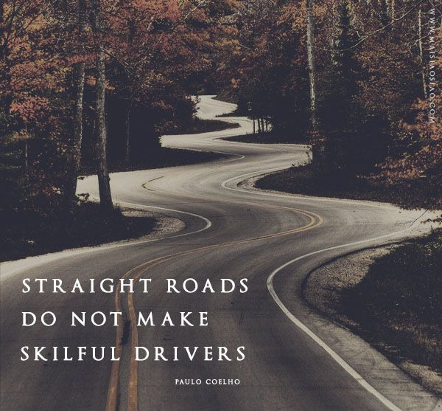
To be continued…..
Word of the Month: Gardyloo
n. Used in Edinburgh as a warning cry when it was customary to through slops from the windows into the streets.
History: Pity the visitor to Scotland unfamiliar with the practice of using what is most likely a French-based term (garde a l’eau! Literally means “look out for the water!”) when dumping slops into the streets.

Ex. The cottage is lovely for it’s bucolic setting.

