Finding Case Studies in the Woulters Kluwer CCH Intelliconnect Database
- If you go to All Content on the left hand side of the page and click “ Human Resources” then enter “ Case Studies” into the Search/Browse box at the top of the page and then click “Go”

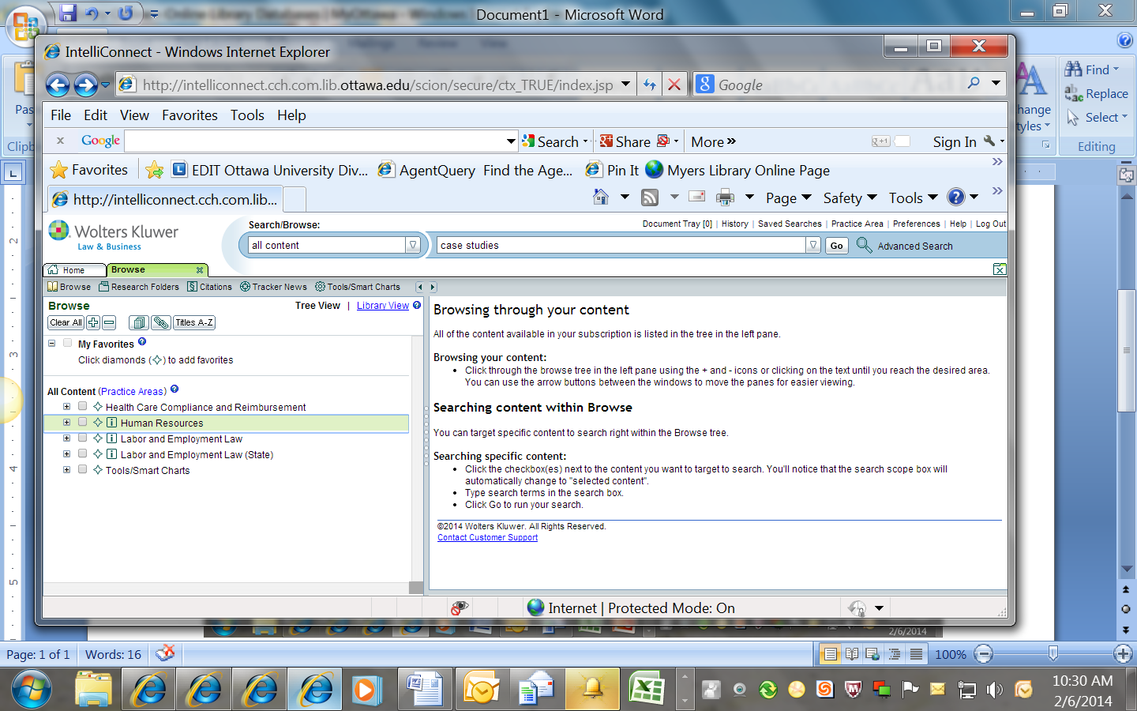

- Once the search results are offered, scroll down until you find “Cases”. If you click on View all the cases you will get case listings
- Also look for “Cases” on the left hand side of the page under the Narrowed results listing. You will note that there are 718 results.
- To limit your case studies try the search case studies AND human resources
