How to search for Case Studies in EbscoHost’s Business Source Premier
- In EbscoHost choose the Business Source Premier Database and then enter your search terms in the box below. If you are searching for a specific topic of case study, please enter it in the search box.
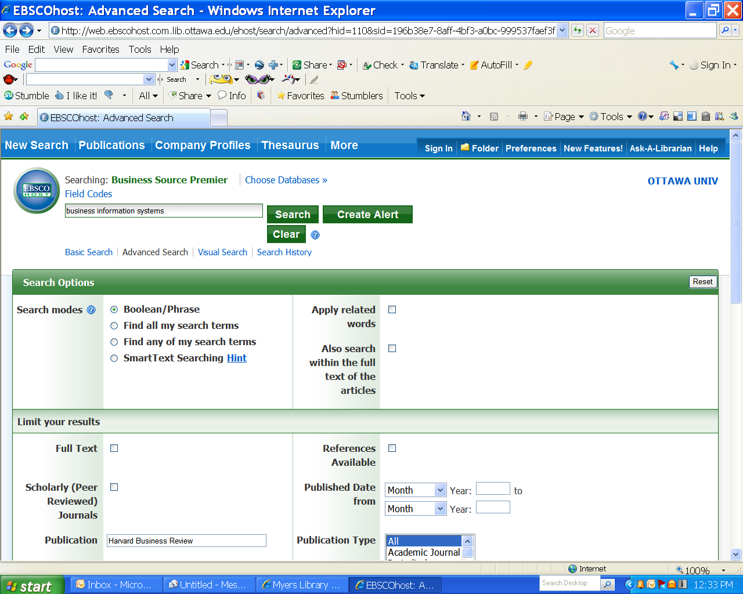
- Make sure that you enter the find the “Publication” box and type your periodical title in the Search box. In this case you are searching for Case Studies from the “Harvard Business Review” so enter the title name without “the” as a prefix in the search box”
- For this search only, do not check the full-text or the scholarly peer-reviewed boxes since the search done in a specific publication “The Harvard Business Review”
- Go to Publication type and make sure the default is set to choose “all”
- The go down to the “Document type and choose “Case Study”
- Then click the green “Search “ button to complete your search
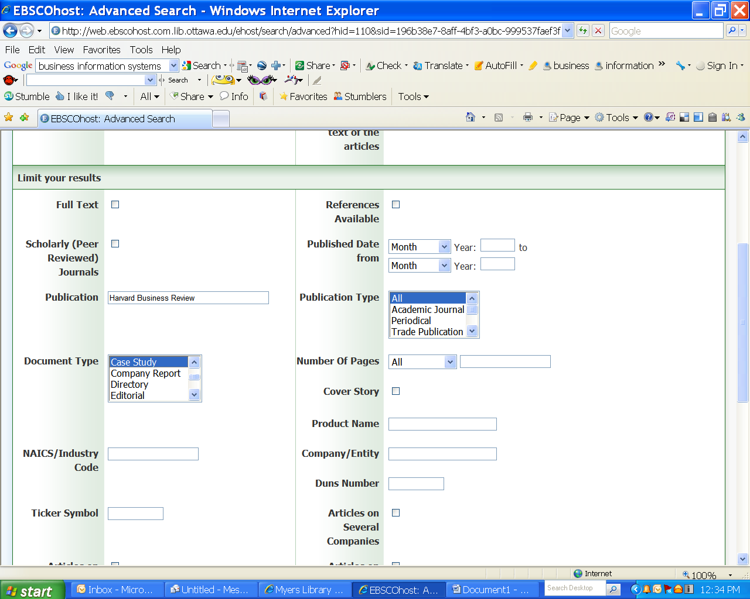
- You could expand your search beyond “ Harvard Business Review” Case Studies to find case studies in other sources
- If you redo your search, but just exclude entering the name of a journal in the Publication box your search will be widened. Note: For MIS searches, use either of the following search terms: Management Information Systems, Business Information Systems or Information Systems in the search box.

