RESEARCH
Findagrave.com

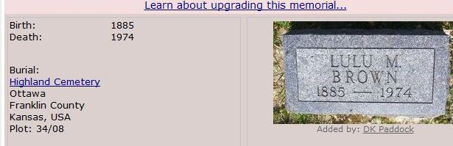
LULU BROWN
509-32-8858 October 30, 1885- July 1, 1974 88 years KS 66067 (Ottawa, Franklin County

Phone conversation with Marion Marsh:
Marion grew up in Ottawa across the street from Lulu Brown. She and her sister both attended OU and had Lulu for a teacher. They thought Lulu was an excellent teacher. She wasn’t chummy with her students and called them all Miss or Mr.
Marion talked with an older woman who has attended 1st UMC in Ottawa her whole life and she doesn’t remember ever seeing Lulu attend there.
Sagamore (1907 yearbook)
Lulu’s picture is shown with the senior class
Her full name is Lulu Marie Brown
President of the class, 1906-07 (doesn’t seem to me that if she transferred in for her senior year that she would be voted president of the class)
Member of Philalethean society

The Ottawan (1910)
Lula Brown is listed as the Academy professor of Latin

Alumni Directory (1886-1922)
Lule’s address is given as 506 E. 4th, Ottawa

Lulu was a faculty member from 1909-1954
As of Jan. 2012 she had the longest tenure of any employee

1918-1919 Lulu’s salary was $1000
in 1931-32 she taught English ( I would guess that after the Academy closed she switched to teaching English but check that out)

