HOW TO USE THE REFWORKS DATABASE AT OTTAWA UNIVERSITY HANDOUT
- GO TO THE ONLINE LIBRARY DATABASES AND GO TO REFWORKS
- CREATE YOUR OWN ACCOUNT USING YOUR OTTAWA UNIVERSITY EMAIL AND CREATE A PASSWORD
- ONCE YOU ARE SIGNED IN CREATE YOUR OWN FOLDER
- GO TO MY FOLDER AND ADD A FOLDER
- CLICK ON THE ADD + ICON TO UPLOAD A DOCUMENT, IMPORT A REFERNCE OR CREATE A NEW REFERENCE

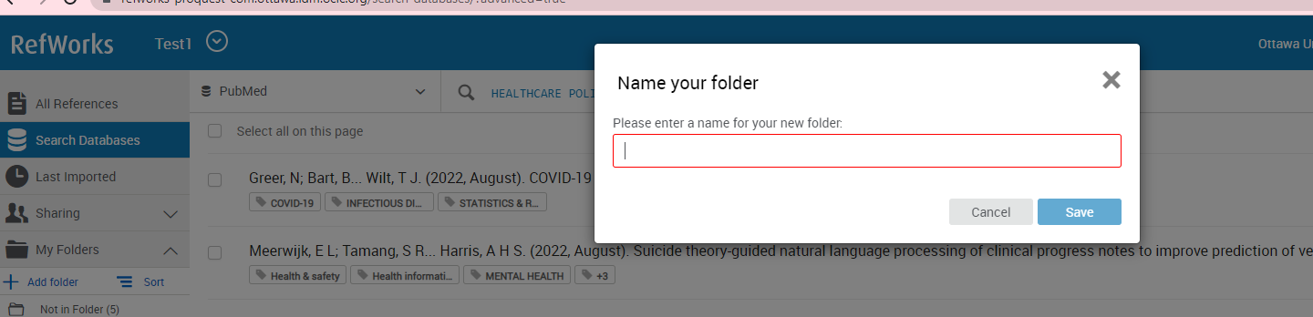

TO UPLOAD A DOCUMENT
GO TO YOUR FOLDERS WHERE YOU HAVE SAVED IT AND UPLOAD IT TO REFWORKS FROM YOUR FOLDERS
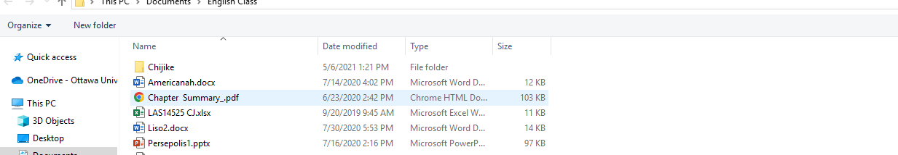

TO IMPORT A REFERENCE FROM A DATABASE GO TO THE DATABASE SUCH AS THE TWO DATABASES ALREADY IN REFWORKS “PUBMED” GO TO SEARCH DATABASES AND ENTER YOUR SEARCH “HEALTHCARE POLICY” IN THE SEARCH
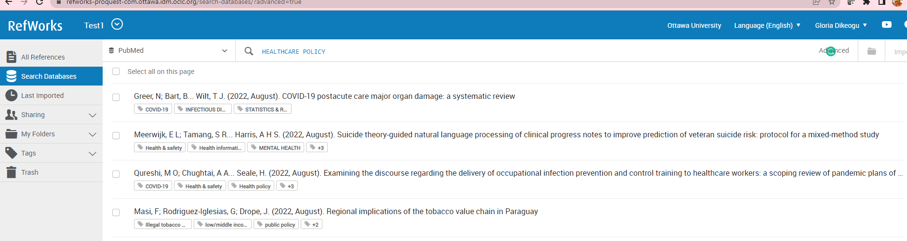
TO USE EBSCHOST IN YOUR SEARCH GO TO CREATE A NEW REFERENCE
YOU WILL SEE “SEARCH FULLTEXT FINDER” CLICK ON IT 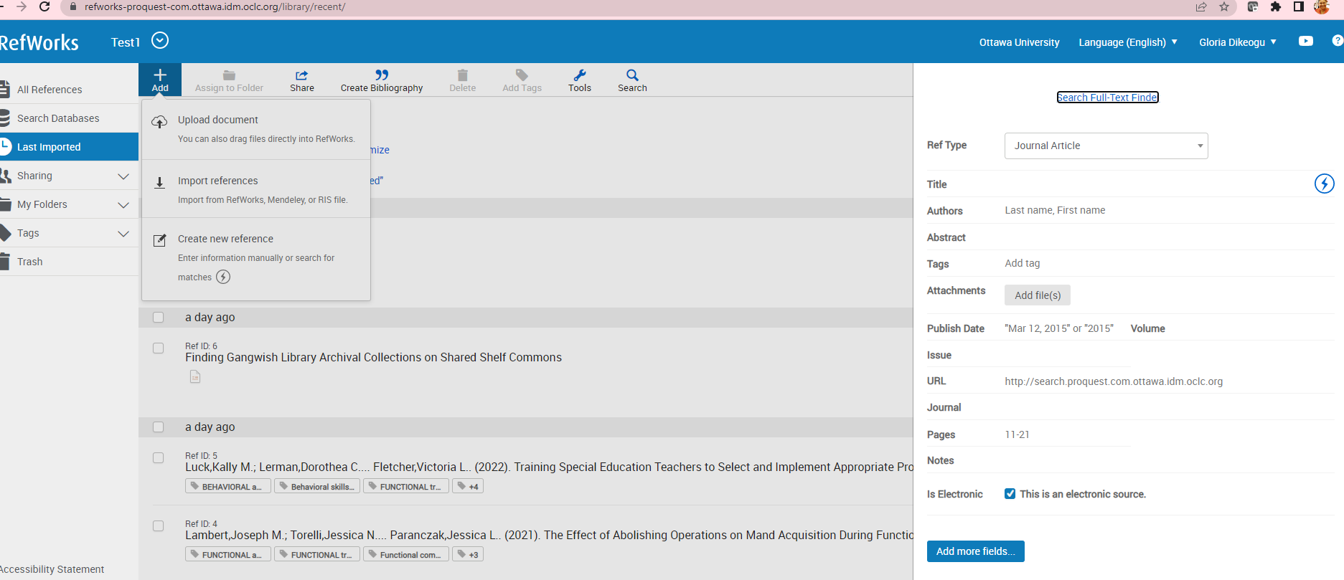
IGNORE THE ERROR NOTE AND GO TO THE “LOGIN AGAIN” LINK. IF YOU CLICK ON IT YOU WILL SEE THE EBSCHOST DATABASES. CLICK ON “EBSCOHOST RESEARCH DATABASES” LINK AND YOU WILL SEE THE LIVE DATABASES FOR YOUR SEARCH.

IN EBSCOHOST CONDUCT YOUR SEARCH FOR “BUSINESS TECHNOLOGY TRENDS” AND AN ARTICLE HAS BEEN CHOSEN BY CLICKING ON THE BLUE + SIGN AND ADDING IT TO THE YELLOW FOLDER

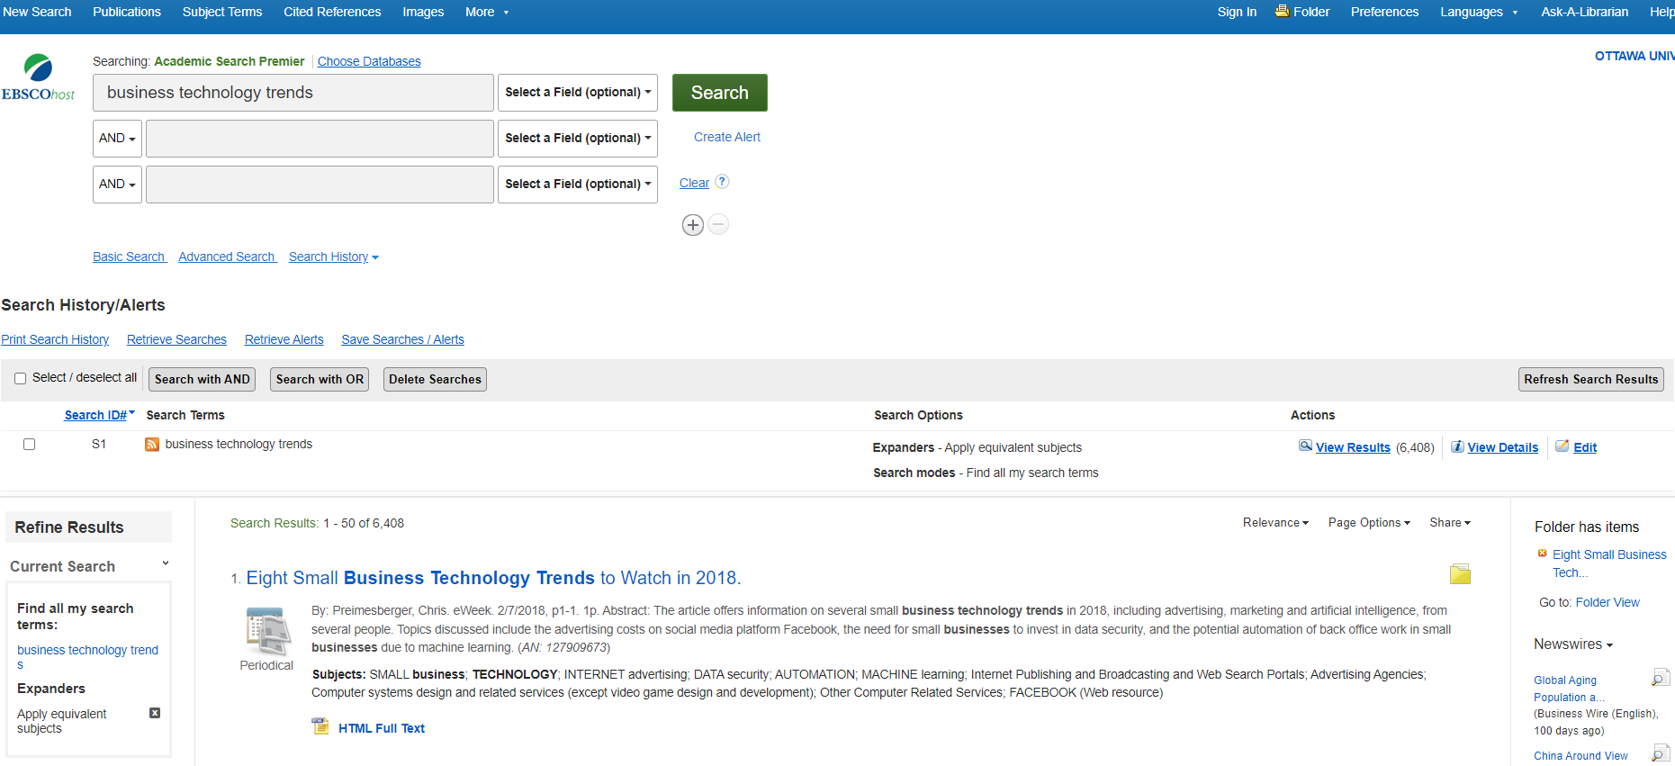

NOW CLICK ON THE FOLDER AND GO TO “EXPORT”
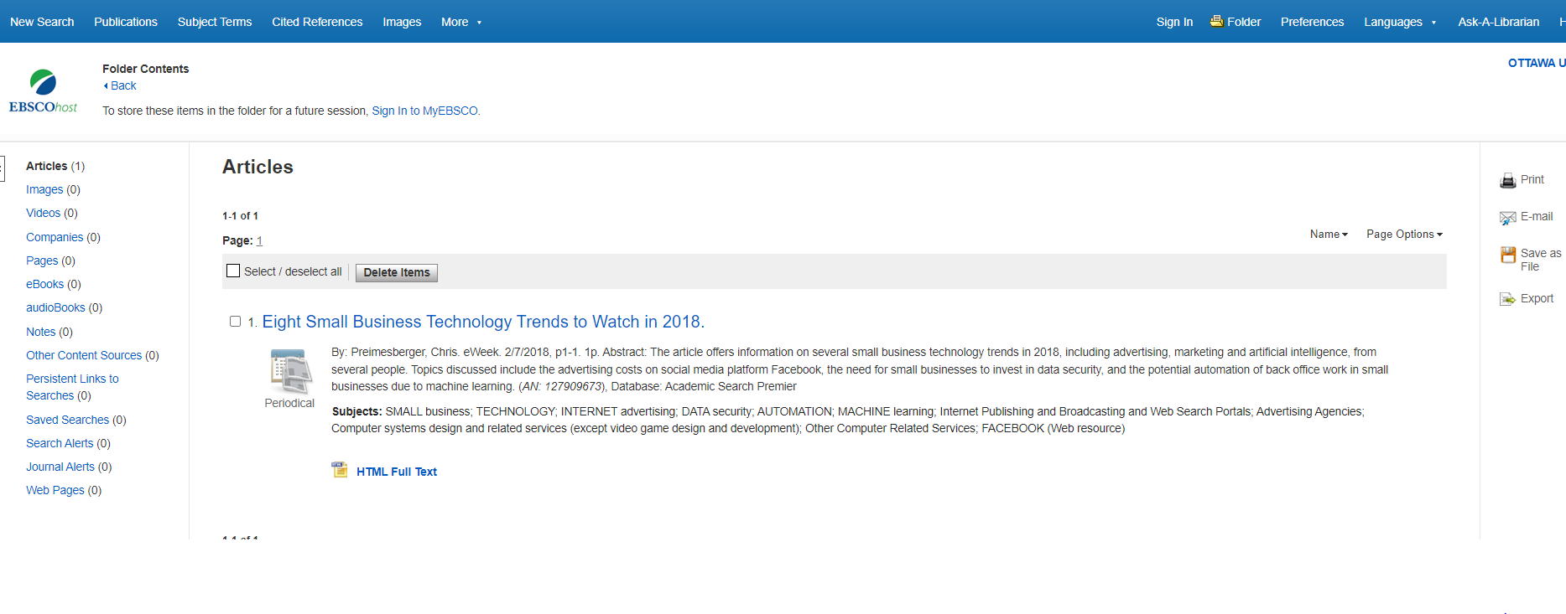
WHEN CLICKING ON EXPORT YOU WILL SEE THE NUMBER OF ARTICLES SAVED TO EXPORT AND A FILE SAYING “DIRECTO EXPORT TO REFWORKS”

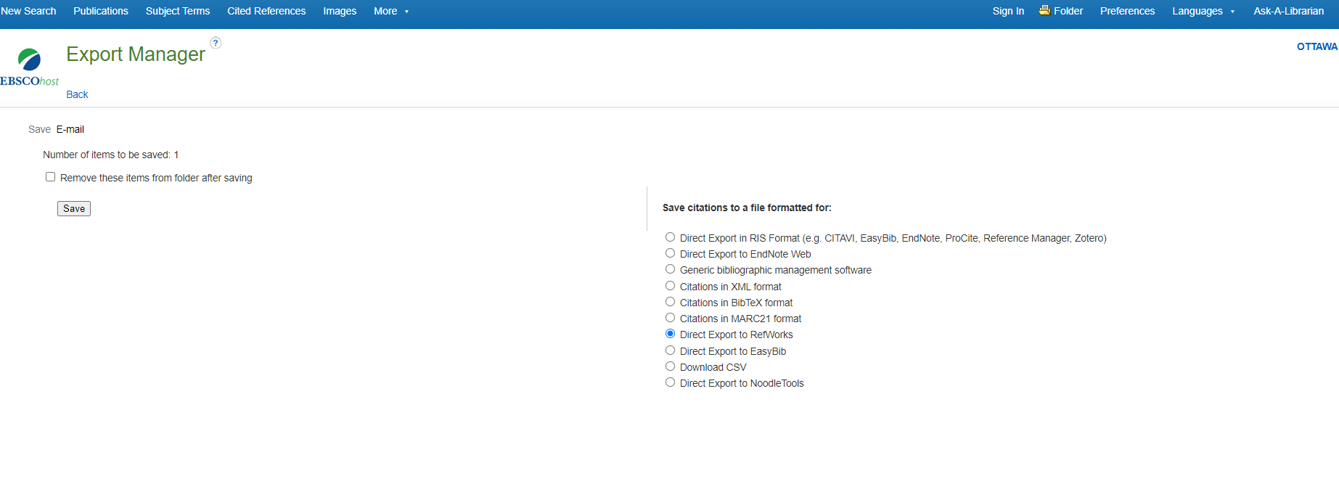

IF YOU CLICK SAVE YOU WILL SEE THIS BUTTON THAT WILL TAKE IT DIRECTLY TO YOUR FOLDER YOU HAVE CHOSEN IN REFWORKS

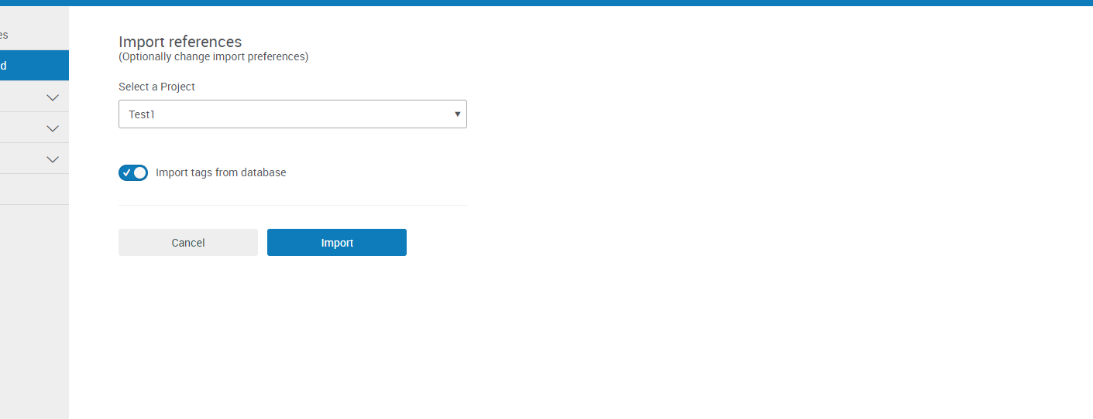

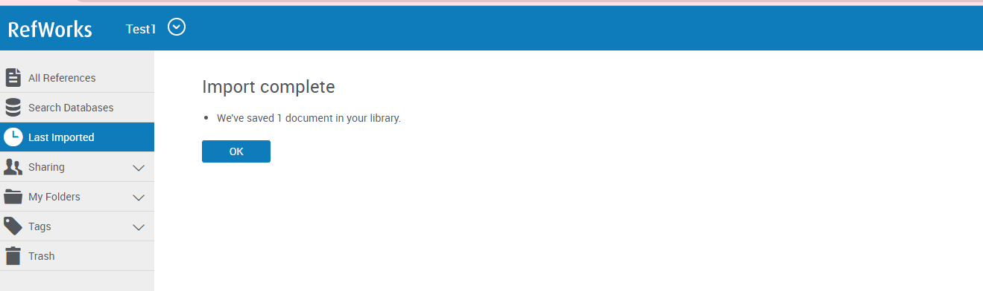

NOW YOU HAVE YOUR IMPORT INTO YOUR FILE CHOSEN IN REFWORKS

